Charles E. Whitright
May 28, 1912 – April 12, 1974

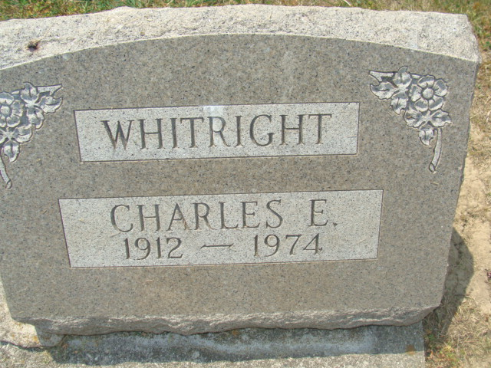
Photo by Alicia Kneuss

FORMER LOCAL RESIDENT DIES
Charles E. Whitright, 61, of Portland, a former Decatur resident, died at 9:15 a.m. Friday at the Jay County Hospital, where he had been hospitalized one week. Mr. Whitright, a contractor, was employed at Kocher Lumber Co., Decatur, for 17 years.
Born in Adams County on May 28, 1912, he was a son of Samuel E. and Ida A. Johnston-Whitright and was married to Frances Miller on August 28, 1968.
Survivors include his wife; three sisters, Mrs. Albert (Niomi) Hey, San Jose, Calif., Mrs. Edward (Thelma) Bertels, Fort Wayne, and Mrs. George (Frieda) Houck, Decatur; and one brother, Harold E. Whitright, route 3, Decatur. One brother preceded him in death.
Funeral services will be held at 1:30 p.m. Monday at the Winteregg-Linn and Haggard Funeral Home, with Rev. Howard Beer officiating. Burial will be in the Decatur Cemetery. Friends may call at the funeral home from 2 to 4 and 7 to 9 p.m. Sunday.

Decatur Daily Democrat, Adams County, Indiana
Saturday, April 13, 1974

