Wilma Arlene (Merriman) Whitman
July 29, 1929 -

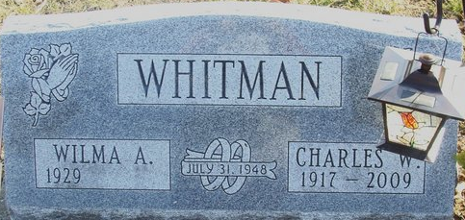
Photo by Alicia Kneuss

Wilma Arlene Merryman
in the Indiana, U.S., Birth Certificates, 1907-1944
Name Wilma Arlene Merryman
Gender Female
Birth Date 29 Jul 1929
Birth Place Blue Creek, Adams, Indiana, USA
Father Leo Roy Merryman; age 26
Mother Blanch Lavena Moore; age 29; 2nd child, both living
Certificate Number 29208
Roll number 40474_356492
Volume Range 56 - 60
**
Indiana, U.S., Marriage Certificates, 1960-2012
Name Wilma Arlene Merriman
Gender Female
Race White; Marriage Age 19
Birth Date 29 Jul 1929; Birth Place Adams, Indiana
Marriage License Date 30 Jul 1948
Marriage Date 31 Jul 1948; Marriage Place Adams, Indiana, USA
Residence Place Decatur, Indiana
Spouse Charles William Whitman

**
Wilma Arlene Merriman from tree Atwood Family Tree
Birth 29 Jun 1929 Decatur, Adams, Indiana, USA
Marriage 31 Jul 1948
Residence 26 Aug 1986 Fort Wayne, Allen, Indiana, USA
Death after Aug 1986
Father Leo Ray Merriman (1903-1986)
Mother Blanche Lavina Moore (1898-1972)
Spouse Charles William Whitman (1917-2009)
8110 People 0 Records 0 Sources

