Richard K. Whitman
December 8, 1948 – February 29, 2008

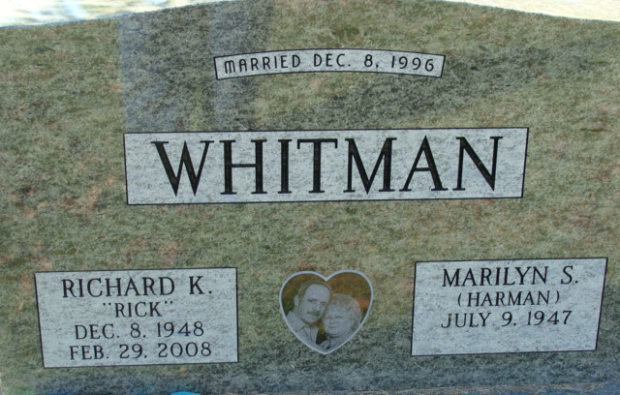
Photo by Alicia Kneuss

Richard K. "Rick" Whitman, 59 of Decatur died at his residence on Friday, February 29, 2008. Rick was the son of the late Arthur H. Whitman and Marjorie R. Myers. He was born in Allen County, Indiana on December 8, 1948. He married Marilyn S. Harman on December 8, 1996.
Rick is survived by his wife Marilyn of Decatur; 3 sons Todd A. Whitman of Van Wert, Ohio, Lincoln C. Whitman of Waynedale, Indiana and Ryan N. (Amber) Whitman of Franklin, Indiana; a daughter Jonette M. Elliott of Decatur, Indiana; 3 step sons Steven W. (Renata) Trout of Grovestown, Georgia, Douglas A. (Meg) Trout of Shepherdsville, Kentucky and Robert E. Lee of Cincinnati, Ohio; a step daughter Melissa A. Trout of Bluffton, Indiana; a brother Stan (Deneice) Whitman of Decatur, Indiana; a sister Mrs. George (Sharol) Pace of Everetts, Kentucky; 12 grandchildren and two great grandchildren.
Rick is preceded in death by his parents and twin brothers.
He attended First United Methodist Church in Decatur and was employed at D & T Trucking in Decatur. He was also a member of the Moose Lodge #1311 and the Eagles Lodge #2653.
Visiting hours are from 4-8 pm Monday, March 3, 2008 at Haggard & Sefton Funeral Home. Funeral service will be at 10:30 am Tuesday, March 4, 2008 also at the funeral home. Rev. Ken Mahan will be officiating. Burial is in Decatur Cemetery.
Memorials are to Family Hospice of Northeast Indiana.
Haggard and Sefton Funeral Home, Adams County, Indiana
March 1, 2008

