Marilyn S. (Harman) Trout-Whitman
July 9, 1947 -

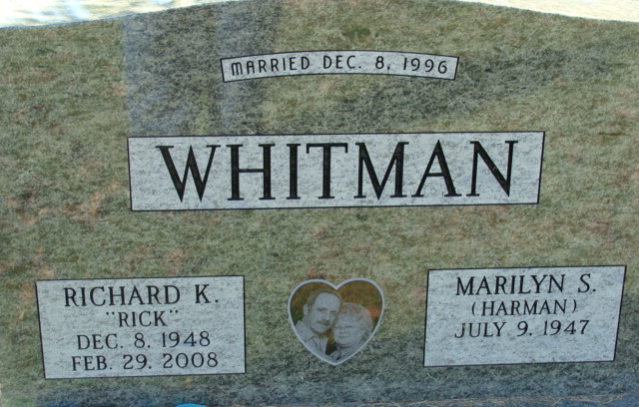
Photo by Alicia Kneuss

John Wayne Trout
in the Indiana, U.S., Marriage Certificates, 1960-2012
Name John Wayne Trout
Gender Male
Marriage Age 20
Birth Date abt 1945; Birth Place Indiana
Marriage Date 4 Sep 1965
Marriage Place Decatur, Adams, Indiana, USA
Spouse Marilyn Sue Harmon
Notes 2 N; Reference Number 1 Bx1444
Reference Number 2 Tr8516; Certificate Number 65000046
**
Indiana, U.S., Marriage Certificates, 1960-2012
Name Marilyn Sue Trout
Gender Female
Marriage Date 15 Sep 1979
Marriage Place Decatur, Adams, Indiana, USA
Spouse James Lee
Description Adams-Madiosn
Notes 2 N; Reference Number 1 Bx1449
Reference Number 2 Tr8060; Certificate Number 79-042753

**
Indiana, U.S., Marriage Certificates, 1960-2012
Name Marilyn Sue Trout [Marilyn Sue Harman]
Gender Female
Marriage Age 42
Birth Date abt 1947; Birth Place Indiana
Marriage Date 12 Aug 1989
Marriage Place Decatur, Adams, Indiana, USA
Father Donald Harman
Mother Alice Harman
Spouse Kevin Eugene Heston
Description Adams-Huntington
Notes 2 N; Reference Number 1 Bx1448
Reference Number 2 Tr8527; Certificate Number 89-027366; Box Number 3h

**
Indiana, U.S., Marriage Certificates, 1960-2012
Name Marilyn S Heston [Marilyn S Harman]
Gender Female
Marriage Age 49
Birth Date abt 1947; Birth Place Decatur, Indiana
Marriage Date 8 Dec 1996
Marriage Place Decatur, Adams, Indiana, USA
Father Donald C. Harman
Mother Alice K. Harman
Spouse Richard K Whitman
Description Wells-Allen
Notes 2 N; Reference Number 1 Bx1450
Reference Number 2 Tr8555; Certificate Number 048239
Box Number Box 5h

