Loretta (Peterson) Whitman-Gause
August 3, 1872 – February 2, 1964

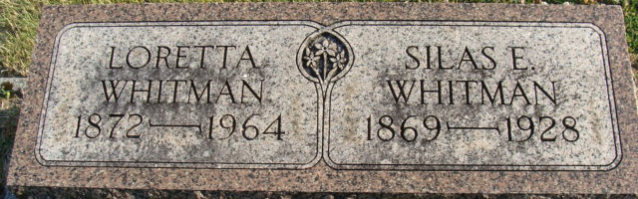
Photo by Alicia Kneuss

Mrs. Loretta Gause, 91, of 2501 Covington Road, died at 8:05 p.m. yesterday at the home of her son, Charles W. Whitman, with whom she lived.
A native of Decatur, Mrs. Gause had lived in Fort Wayne with her son for about 10 years. She was a member of the First Methodist Church, Decatur, and of the Moose Lodge, Decatur.
Surviving besides her son are a brother, Frank Peterson, Decatur; and five grandchildren.
The body is at the Zwick Funeral Home, Decatur.
Journal Gazette, Allen County, Indiana
Monday, February 3, 1964
**
Indiana, U.S., Death Certificates, 1899-2017
Name Loretta Gause
[Loretta Peterson]
Gender Female
Race White
Marital Status Widowed
Age 91
Birth Date 3 Aug 1872
Birth Place Indiana
Death Date 2 Feb 1964
Death Place Fort Wayne, Allen, Indiana, USA
Death Registration Date 1964
Father Sylvester Peterson
Mother Eliza Blossom
Informant Charles W. Whitman; son; Fort Wayne, Indiana
Burial February 5, 1964; Decatur Cemetery; Decatur, Indiana

