Charles W. Whitman
February 9, 1917 – June 17, 2009

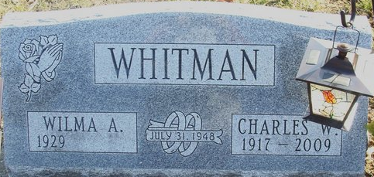
Photo by Alicia Kneuss

Charles W. Whitman, 92, of Fort Wayne, Indiana passed away Wednesday, June 17, 2009 at Lutheran Hospital. Born on February 9, 1917 in Decatur, Indiana he was the son of the late Silas & M. Loretta (Peterson) Whitman. Charles married Wilma A. Merriman on July 31, 1948.
Charles is survived by his wife Wilma A. Whitman of Fort Wayne, three sons Dennis L. (Donna) Whitman of New Haven, Daniel L. Whitman of Fort Wayne and Dean L. (Mary) Whitman of Colorado Springs, CO; two daughters Mrs. Donnita (Danny) Mills and Mrs. Deanna (Randall) Brumbaugh both of Ft. Wayne; 9 grandchildren, three step grandchildren and 14 great grandchildren.
Charles was a member of Elmhurst Church of the Nazarene in Fort Wayne, served on the Trustee and was a Sunday school teacher for many years. He retired in 1983 from St. Frances College as a Housekeeping supervisor.
Calling hours are from Noon - 5 pm Sunday, June 21, 2009 at Haggard & Sefton Funeral Home in Decatur. Funeral services will be held on Monday, June 22, 2009 at 2:00 pm also at the funeral home. Rev. Richard Dickson will be officiating and burial will be in Decatur Cemetery in Decatur.
Memorials are to Elmhurst Church of the Nazarene.
Haggard and Sefton Funeral Home, Adams County, Indiana
June 18, 2009

