Vivian G. (Acker) White
January 18, 1912 – May 17, 1944

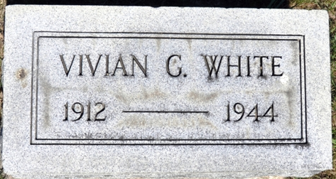
Photo by Deb Curry
Vivian Acker White
in the Indiana, U.S., Death Certificates, 1899-2017
Name Vivian Acker White
[Vivian Acker Acker]
Gender Female
Race White
Marital Status Married
Age 32
Birth Date 18 Jan 1912
Birth Place Decatur, Adams Co Indiana
Death Date 17 May 1944
Death Place Decatur, Adams, Indiana, USA
Death Registration Date 1944
Father Floyd Acker
Mother Zona Suman
Spouse Russell O White; age 35
Informant Russell O. White; Decatur, Indiana
Burial May 21, 1944; Decatur Cemetery

