Niles Allen “Bud” White
May 22, 1906 – April 1, 1934

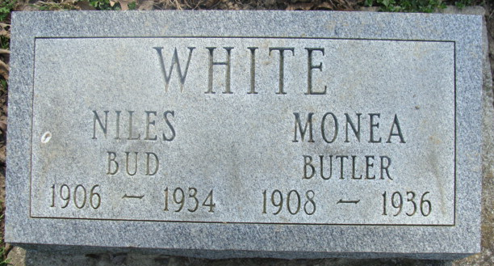
Photo by Alicia Kneuss
"Bud" White is Death's Victim
Well Known Decatur Young Man Dies Sunday after Extended Illness
Niles "Bud" White, 27, an employee of the Schafer Hardware Company and a well-known young man of this city died at the Adams County Memorial Hospital yesterday evening at 5:20 o'clock, following a several week's illness. Death was due to uremic peritonitis. Mr. White had been confined to home, west of Decatur, for several weeks before being removed to the local hospital. He had been ailing with high blood pressure for several years.
White spent practically is entire life in Decatur and Adams County. He attended the Decatur Elementary and High School and Indiana University. He took an active part in band, orchestra and other musical organizations of the city. He was a prominent member of the Zion Reformed Church and was the teacher of a Sunday School class, sang in the choir of the church and in church quartets. For a number of years he had served as a scout master of the local Boy Scout troop. He was a member of the Loyal Order of Moose.
Niles Allen White was born in Portage, Ohio, on May 22, 1906, a son of Mr. and Mrs. Robert Henry White. His father preceded him in death eight years ago. He had resided in Adams County since he was 18 months old. His marriage to Miss Monai Butler of this city took place on August 12, 1929, and two children were born to the union, Ruth Ann and William Robert.
Survivors include the widow, the mother, two children, and a brother, Robert White, west of Decatur.
Funeral services will be held at 1 o'clock Wednesday afternoon at the William Butler residence, 103 South Eighth Street, and at 1:30 o'clock at the Zion Reformed Church. Rev. C. M. Prugh will officiate, assisted by Rev. David Grether and Rev. F. W. Rupnow. Burial will be made in the Decatur Cemetery.
The body will be removed to the William Butler residence on Eighth Street Tuesday and may be viewed after 7 o'clock Tuesday night.

Decatur Daily Democrat, Adams Co, Indiana
Monday, April 2, 1934

**
Indiana, Death Certificates, 1899-2011
Name: Niles Allen White
Gender: Male
Race: White
Age: 27
Marital status: Married
Birth Date: 22 May 1906
Birth Place: Ohio
Death Date: 1 Apr 1934
Death Place: Decatur, Adams, Indiana , USA
Father: Robert Henry White
Mother: Cora Kittle
Informant: Mrs. Niles White; Decatur, Ind.
Burial: April 4, 1934; Decatur Cem.

