Nellie E. (Myers) White
May 1, 1901 – May 30, 1997

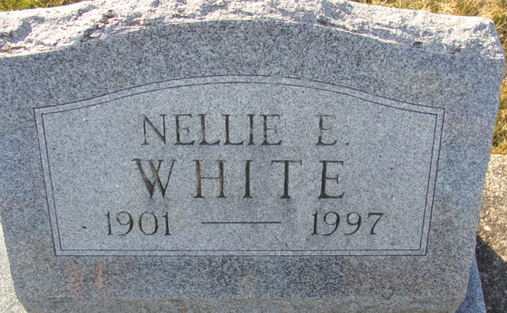
Photo by Alicia Kneuss
Nellie E. White, 96, died Friday at Adams County Memorial Hospital. She worked at General Electric Co., retiring in 1961.
Surviving are four daughters, Betty Roberts and Beverly Sue Stetler, both of Decatur, Barbara Leistner of Chattanooga, Ohio, and Burdetta Jo Daniels of Huntington; 15 grandchildren; 28 great-grandchildren and 10 great-great-grandchildren.
Services at 1 p.m. Monday at Zwick-Sefton & Jahn Funeral Home, with calling from 11 a.m. to 4 p.m. and 6 to 8 p.m. Sunday. Burial in Decatur Cemetery.
Memorials to Adams County Home Health.

Journal Gazette, Allen County, Indiana
May 31, 1997
**
Indiana, U.S., Death Certificates, 1899-2017
Name Nellie E. White
[Nellie E. Myers]
Gender Female
Race White
Marital Status Divorced
Age 96
Birth Date 1 May 1901
Birth Place Willshire, Ohio
Death Date 30 May 1997
Death Place Decatur, Adams, Indiana, USA
Death Registration Date 1997
Father Josiah Myers
Mother Rosa C. August
Informant Betty Roberts; daughter; Decatur, Indiana
Burial June 2, 1997; Decatur Cemetery; Decatur, Indiana

