Cora Constance (Kittle) White
April 15, 1881 – September 8, 1945

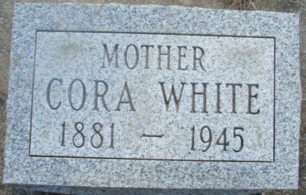
Photo by Alicia Kneuss
Cora C White
Death • Illinois, Cook County Deaths, 1871-1998
Name Cora C White
Sex Female
Age 64
Birth Date 15 April 1881; Birthplace Mercer, Ohio
Residence Place Harvey, Cook, Illinois
Address 14828 Morgan
Burial Date 11 Sep
Burial Place Decatur, Indiana
Marital Status Widowed
Occupation Housewife
Race White
Father's Name Kittse [sic -Kittle]
Spouse's Name Robert H
Informant's Name Robert N White
Event Date 8 September 1945
Event Place Maplewood, Southampton, York, New Brunswick, Canada
Event Place (Original) Harvey, Cook, Illinois, Illinois, United States
Funeral Home W E Kerr And Company
Cemetery Maplewood
Entry Number 124
**
Cora Constance Kittle from tree Rogers Family Tree
Birth 27 Nov 1875 Franklin, Mercer, Ohio, USA
Marriage 23 Jul 1899 Mercer, Ohio, USA
Residence 1940 Decatur, Adams, Indiana, USA
Death 8 Sep 1945 Harvey, Cook, Illinois, USA
Father Jacob Wood Kittle (1830-1915)
Mother Susannah Chase (1836-1926)
Spouse Robert Henry White (1878-1926)

