Don E. Whitaker
October 1, 1916 – October 9, 1999

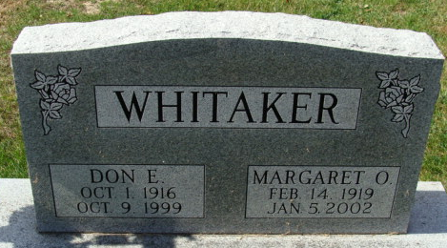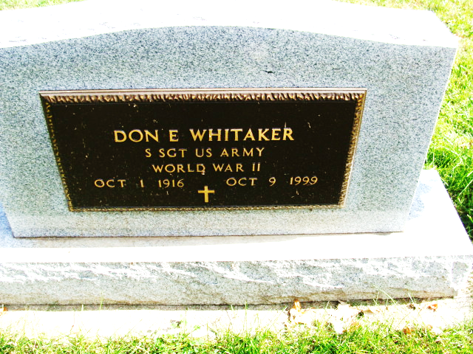
Photo by Alicia Kneuss

Don E. Whitaker, 83, of Decatur, a retired salesman, died Saturday, Oct. 9, 1999, at Adams County Memorial Hospital. The St. Francis, Ark., native worked for Gambles and Habegger Schafer Brothers.
Surviving are his wife, Margaret O.; a son, Thomas E. of Oviedo, Fla.; a daughter, Carol Ann Brown of Stockbridge, Mich.; a brother, Joe of Detroit; sisters Ruth Ann Garner of Blytheville, Ark., and Imogene Henderson of Blytheville, Ark.; and four grandchildren.
He was preceded in death by a brother, Albert.
Services are 11 a.m. Tuesday at Haggard & Sefton Funeral Home, Decatur, with calling from 2 to 4 and 6 to 8 p.m. today. Burial will be in Decatur Cemetery.
Memorials are to Adams County Heart Club.

News-Sentinel, Allen County, Indiana
Monday, October 11, 1999

