Melvin Albert “Red” Wheeler, Jr.
January 30, 1931 – August 12, 2020

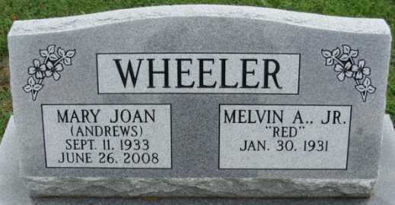
Photo by Alicia Kneuss

Melvin Albert “Red” Wheeler Jr, 89, of Decatur, Indiana passed away on Tuesday, August 12, 2020, at St. Luke’s Hospital in Chesterfield, Missouri. He was born on January 30, 1931, in Montebello, California to the late Melvin Wheeler Sr. and the late Hazel (Gierhart) Wheeler. Red was united in marriage to Mary Joan Andrews on June 30, 1951, in Van Wert, Ohio and she preceded him in death on June 26, 2008.
He was a member of the American Legion Post #43, Decatur.
Red was a machinist at the Decatur General Electric Plant from 1955 until the plant closed in 1989. In his spare time, Red was a well-known machinist who sharpened anything that could be sharpened.
Red was an honorably discharged member of the United States Air Force, serving from 1951-1955 during the Korean War.
Red was immensely proud of his family, especially his grandchildren. Red enjoyed golfing in his younger years. He was a very quiet man who took pride in his work and was in his “element” when working in his shop. He was also fiercely independent, seeking help only as a “last resort” and would not let physical ailments slow him down.
Survivors include his son, Richard (Margaret) Wheeler of St. Charles, Missouri; daughter, Angela Wheeler of St. Charles, Missouri; grandson, Luke (Sarah) Wheeler of O’Fallon, Missouri; granddaughter, Anne Wheeler of St. Charles, Missouri; brother, Laurence (Dora Lou) Wheeler of Portland, Oregon; and a sister, Mary (Ray) Hingson of Pinellas Park, Florida.
Red was preceded in death by three brothers, Charles, Fred and Lloyd Wheeler; four sisters, Ruth Wurst, Bernadine Wheeler, Pauline Proklovich, and Violet Kimmey.
A graveside service will be held at 11:00 a.m. Wednesday, August 19, 2020, at the Decatur Cemetery with Pastor Harold Klinker officiating. Friends will be received from 5-8 p.m. Tuesday, August 18, 2020, at the Zwick & Jahn Funeral Home in Decatur.
Preferred memorials are to Adams County Community Foundation – Cancer Fund.

Zwick & Jahn Funeral Home, Adams County, Indiana
August 14, 2020

