Mary Joan (Andrews) Wheeler
September 11, 1933 – June 26, 2008

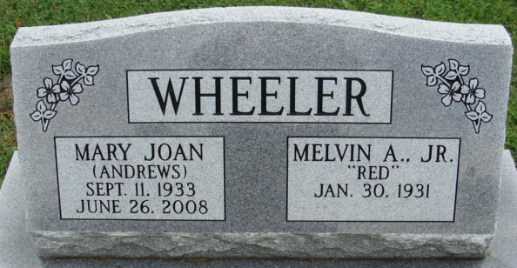
Photo by Alicia Kneuss

Mary Joan Wheeler, 74 years old of Decatur, Indiana , passed away at 3:30 a.m. on Thursday, June 26, 2008 at her residence. Joan was born on Monday, September 11, 1933 in Decatur, Indiana the daughter of the late Richard Andrews and the late Agnes O. (Troutner) Andrews. She married Melvin "Red" Wheeler Jr. on June 30, 1951 in Van Wert, Ohio and he survives.
Joan was formerly employed by Decatur General Electric in the office and was also a homemaker.
Surviving are her husband, Melvin "Red" Wheeler Jr. of Decatur, Indiana, son, Richard (Margaret) Wheeler of St. Charles, Missouri, daughter, Angela Wheeler of St. Charles, Missouri, grandson, Luke Wheeler, and granddaughter, Annie Wheeler.
Private Graveside Services will be held on Sunday, June 29, 2008 with Chaplain Christopher Thurow officiating. Interment will be in the Decatur Cemetery. Friends will be received from 5-8 p.m. Saturday, June 28, 2008 in the Zwick and Jahn Funeral Home, Decatur, Indiana.
Preferred memorials are to Family Hospice of Northeast Indiana.

Zwick & Jahn Funeral Home, Adams County, Indiana
June 27, 2008

