William Arnold Wetter
September 12, 1836 – January 6, 1916

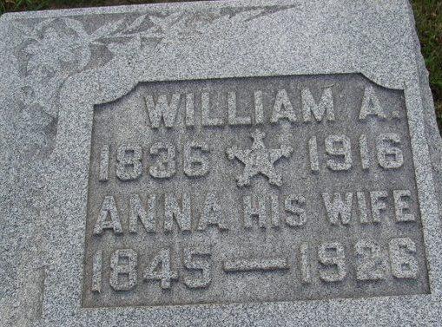
Photo by Alicia Kneuss
Wm A Wetter
in the Indiana, U.S., Death Certificates, 1899-2017
Name Wm A Wetter
Gender Male
Race White
Marital Status Married
Age 79
Birth Date 12 Sep 1836
Birth Place Switzerland
Death Date 6 Jan 1916
Death Place Decatur, Adams, Indiana, USA
Death Registration Date 1916
Parents Unknown
Spouse Anna
Informant Miss Nettie Wetter; Decatur, Indiana
Burial January 8, 1916; Decatur Cemetery
**
William Arnold Wetter from tree CROOKED BRANCHES
Birth 12 Sep 1836 Tegerfelden, Aargau, Switzerland
Marriage 12 Sep 1882 Allen, Indiana, USA
Residence 23 Apr 1910 Decatur, Adams, Indiana, USA
Death 5 Jan 1916 Decatur, Adams, Indiana, USA
Record information.
Father Andreas Wetter (1797-1869)
Mother Mary Meyer (1795-1851)
Spouse Anna Werder (1845-1926)
**
WILLIAM A. WETTER, farmer, section 36, Root Township, owns forty acres of land in that township. He was born in Switzerland, September 12, 1836, and was nineteen years of age when he came to America. He settled in Seneca County, Ohio, living there one year, took a tour through the Northwestern States, was absent two years, then returned to Switzerland. After six months' sojourn in his native country he came back to America, accompanied by his father and two sisters, the mother being deceased, and purchased eighty acres of land in Union Township. The farm is now owned by John Speeler and Andra Niblick. The father returned to Switzerland in 1860, and died there in 1869, aged about seventy-two years.
The parents of our subject were Andrew and Mary (Myers) Wetter. The mother was born in Switzerland in 1795, and died in1851. The two sisters who came to America were Elizabeth and Fanny. Elizabeth was married in 1859 to Jacob K. Myer, and she died in California, whither they had removed soon after marriage. Fanny was married in 1859 to George Speeler; her husband died in hospital at Jeffersonville, Indiana, during the war. For a second husband she married Joseph Speeler, who is also deceased.
William A. was first married to Anna E. Struby, October 6, 186-, who was born in Switzerland in 1837, and came to America in 1855. She was married in Tifflin, Ohio, and died in Union Township January 9, 1879, leaving one child, Mary E., born March 20, 1871. Immediately after the death of his wife, Mr. Wetter went to California, taking his child with him. He remained there three years engaged in farming, and in 1882 returned to Adams County, leaving his daughter with Jacob K. Myers, who is a farmer there. September 12, 1882, he was married to Mrs. Anna Heiptley, widow of Rudolph Heiptley, who was born in Biberstein, Switzerland, December 31, 1838, and came to America when twenty years of age, settling in Attica, Ohio, where he learned the trade of blacksmith. He was married January 30, 1866, and died September 23, 1877, in New Washington, Crawford County, Ohio, of consumption. He left one daughter, now the wife of Wesley Stults. Mrs. Wetter was born March 23, 1845, in Philadelphia, and when four years of age removed with her parents to Seneca County, Ohio, where she was reared and twice married. Her parents were Henry and Anna (Myers) Werder. Both parents were born in Switzerland, the father in 1812, and died in 1870. The mother came to America when nine years old, and died February 28, 1873. Mr. and Mrs. Wetter have one child, Letta, born October 2, 1883. Both families are of German origin.
Biographical and Historical Record - Adams and Wells Co. Indiana, Lewis Publishing Co. Chicago, IL 1887

