Anna (Werder) Wetter
March 23, 1845 – January 24, 1926

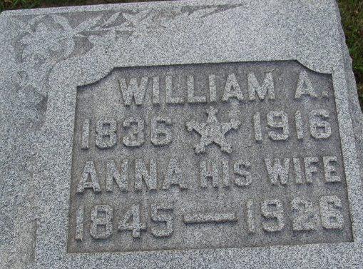
Photo by Alicia Kneuss
Anna Wetter
in the Indiana, U.S., Death Certificates, 1899-2017
Name Anna Wetter
[Anna Werder]
Gender Female
Race White
Marital Status Widowed
Age 80
Birth Date 23 Mar 1845
Birth Place Pennsylvania
Death Date 24 Jan 1926
Death Place Washington, Adams, Indiana, USA
Death Registration Date 1926-1927
Father Henry Werder
Mother Anna Myers
Informant Ferd Letter; Decatur, Indiana
Burial January 26, 1926; Decatur Cemetery

