James Martin Westveld
June 17, 1887 – July 4, 1961

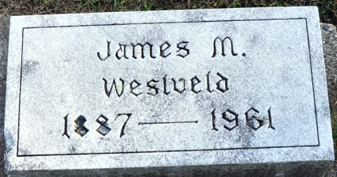
Photo by Deb Curry
Former Decatur Man Is Taken By Death
James Westveld, 75, former Decatur resident, died at 4 a.m. Tuesday at the Grand Rapids, Mich., hospital following a long illness. He had been hospitalized for the past four months.
A native of Zeeland, Mich., Mr. Westveld came to Decatur with Will Kramer to open up the Holland-St. Louis Sugar factory. A chemist, he stayed here until the sugar factory closed. He then moved to Grand Rapids, where he opened a drug store.
Mr. Westveld was married at Decatur to Miss Marie Patterson, daughter of Mr. and Mrs. J. C. Patterson, who preceded him in death in 1949. One daughter, Mrs. Robert Laug, four grandchildren, and one brother, Robert Westveld, survive.
Funeral services will be held in Grand Rapids Thursday afternoon at the Evangelical and Reformed Church there. Graveside rites will be held at the Decatur Cemetery at 2 p.m. Friday, with the Rev. William C. Feller officiating.
Decatur Daily Democrat; Adams County, Indiana
Wednesday, July 5, 1961

**
James Martin Westveld from tree Morgan-Schoettmer Family
Birth 17 Jun 1887 Zeeland, Ottawa, Michigan, USA
Marriage 25 Aug 1920 Indiana, USA
Residence 1942 Grand Rapids, Kent, Michigan, USA
Death 1961
Father Ralph Westveld (Born 1861)
Mother Mary Westveld (Born 1864)
Spouse Dora Marie Patterson (1884-1949)

