Mary Jane (Wiens) West
December 28, 1927 – September 7, 2014

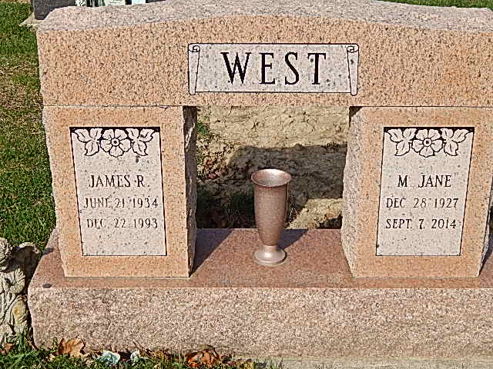
Photo by Alicia Kneuss
Mary Jane West, 86 of Decatur, IN died on Sunday, September 7, 2014 at Swiss Village in Berne. Mary Jane was born on December 28, 1927 in Corn, Oklahoma to the late Aaron and Mary Wiens.
Mary Jane retired from General Electric.
She is survived by four sons, Jim Berry of Sparks, NV, Don West, Tony West and Jeff West all of Decatur, IN; two daughters; Jean (Troy) Roberts of Ft Wayne, IN and Bev Berry of Decatur, IN; 12 grandchildren, 26 great grandchildren and 6 great great grandchildren. She was preceded in death by four brothers, a sister and two grandchildren.
Funeral service will be at 10:30 a.m. Tuesday, September 9, 2014 at Haggard-Sefton & Hirschy Funeral Home with calling prior at 10:00 a .m. Pastor Eugene Martin will be officiating and burial will be in Decatur Cemetery.
Memorials are to Swiss Village or Adams County Community Foundation Alzheimer’s Angel Fund.

Haggard & Sefton Funeral Home, Adams County, Indiana
September 8, 2014

