James Robert West, Jr.
June 21, 1934 – December 22, 1993

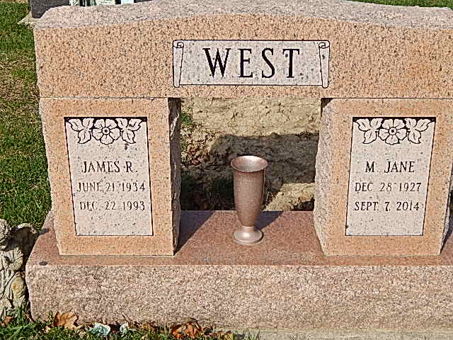
Photo by Alicia Kneuss
DECATUR – James R. West, 59, of Lancaster, Calif., a former 30-year resident of Decatur, died Wednesday at Lancaster Hospital, Lancaster, Calif. He was a former employee of Royal Lace Paper Co., Fort Wayne.
Surviving are four sons, Donald and Jeffrey, both of Decatur, Anthony of Berne, and Jim Berry of Danville, Calif.; two daughters, Jean Renee Roberts of Fort Wayne and Beverly Berry of Decatur; his mother, Violet Baker of Lancaster; two sisters, Esther Stickler and Wanda Kliever, both of Lancaster; two brothers, Edward of Dayton, Ohio and Elmer of San Diego; 12 grandchildren; four step grandchildren; and four great-grandchildren.
Private services today. Burial in Decatur Cemetery. Arrangements by Zwick-Sefton & Jahn Funeral Home, Decatur.

Journal Gazette, Allen County, Indiana
Monday, December 27, 1993

**
California, U.S., Death Index, 1940-1997

Name James Robert West
Social Security # xxx
Gender Male
Birth Date 21 Jun 1934
Birth Place Kentucky
Death Date 22 Dec 1993
Death Place Los Angeles
Mother's Maiden Name Baker

**
U.S., Social Security Applications and Claims Index, 1936-2007

Name James Robert West Jr
Gender Male
Race White
Birth Date 6 Jun 1934
Birth Place Lackey Floyd, Kentucky
Death Date 22 Dec 1993
Father James R West
Mother Violet Baker
SSN xxx
Notes May 1951: Name Listed As James Robert West; 30 Sep 1986: Name Listed As James Robert West Jr; 28 Dec 1993: Name Listed As James R West

