Donna K. (Mountz) West
September 28, 1939 – August 11, 2011

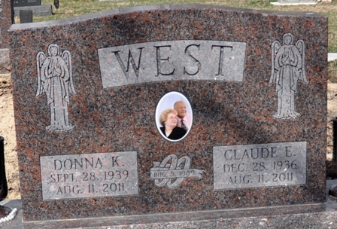
Photo by Deb Curry
Claude E. West, 74, and Donna K. West, 71, both of Decatur passed away early Thursday morning, August 11, 2011 at their residence. Claude was born on December 28, 1936 in Bonnieblue, Kentucky to the late Walter West and the late Rose (Parks) West. He was employed at Decatur Casting from 1972 to 1998.
Donna was born on September 28, 1939 in Patriot, Indiana to the late Merlyn Mountz and the late Irene (Courtney) Mountz. She had worked at CTS in Berne, Indiana and previously with General Electric in Decatur for twenty years. For the past five years, she was employed at Woodcrest.
Claude and Donna were married on August 4, 1989 in Decatur, Indiana and they both attended the Pentecostal Way Church in Van Wert, Ohio. Donna was also a past member of the Eastern Star and the White Shrine.
Survivors include Claude’s children, James L. (Dena) West of Dequeen, Arkansas; Randy (Denise) West of Dover, Arkansas; Vernon West of Fort Wayne, Indiana; & Brenda (Scott) Strickler of Decatur, Indiana; Donna’s children, Marla K. (Ken) Brunsman of Cincinnati, Ohio & J. Todd McSwain of Decatur, Indiana. Together, they have ten grandchildren and seven great-grandchildren. Other survivors include Claude’s siblings Donald L. (Louise) West of Bluffton, Indiana; Charles (Donna) West of Fort Wayne, Indiana; Stella (James) Masterson of Bluffton, Indiana; Pauline Rothgeb of Fort Wayne, Indiana; Midge (Huey) Ginter of Liberty Center, Indiana; & Bernice (Larry) Wine of Fort Wayne, Indiana and Donna’s siblings, Irvin E. (Gail) Mountz of Decatur, Indiana; Lucian R. (Rita) Mountz of Decatur, Indiana; & Judy A. Liter of Decatur, Indiana.
Funeral services will be held at 1:00 p.m. Monday, August 15, 2011 in the Zwick & Jahn Funeral Home, Decatur with Pastor William Watson officiating. Interment will follow in the Decatur Cemetery. Family & friends will be received from 12 noon until 5:00 p.m. on Sunday in the Zwick & Jahn Funeral Home, Decatur.
Preferred memorials are to the Adams County Community Foundation – Diabetes Fund.

Zwick & Jahn Funeral Home, Adams County, Indiana
August 12, 2011

