Darlene L. (Kaehr) West
May 4, 1941 – April 13, 2008

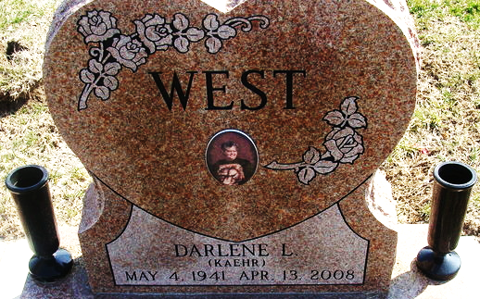
Photo by Alicia Kneuss
Darlene L. West, 66, a former Decatur resident, died Sunday in The Village of Heritage Nursing Home at Monroeville. She was born in Adams County on May 4, 1941, to Roy L. and Maxine Tinkham Kaehr.
She worked at Decatur Industries and was a member of the Living Word Temple in Decatur.
Surviving are two sons, David W. and Mark A. Linnemeier of Fort Wayne; three sisters, Mrs. Clair (Gloria S.) Inniger, Patricia A. Ludy, and Mrs. Bobby (Cheryl A.) Jackson, all of Decatur; four grandchildren; three step grandchildren; and two great-grandchildren. A brother is deceased.
Funeral services will be held at 2 p.m. Wednesday in Haggard and Sefton Funeral Home, with burial in Decatur Cemetery. Visiting hours are 10 a.m.-2 p.m. Wednesday in the funeral home.
Preferred memorials are to the Living Word Temple.

Decatur Daily Democrat, Adams County, Indiana
Monday, April 14, 2008

