Ralph Leo Wertzberger
June 7, 1894 – June 9, 1895

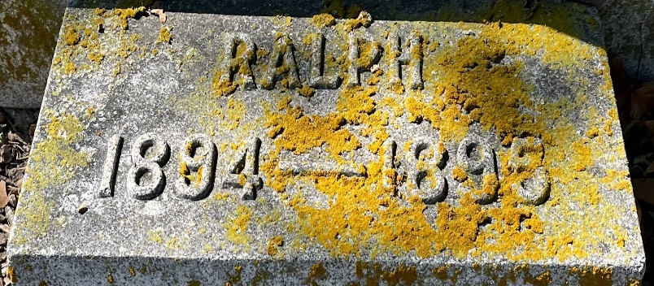
Photo by Alicia Kneuss

Ralph Leo Wertzberger from tree Cooper/Foulks Family Tree
Birth 7 Jun 1894
Death 9 Jun 1895
Father Joseph Leo Wertzberger (1870-1896)
Mother Elsie Dana Hughes (1877-1943)

