Joseph Leo Wertzberger
1870 – March 26, 1896

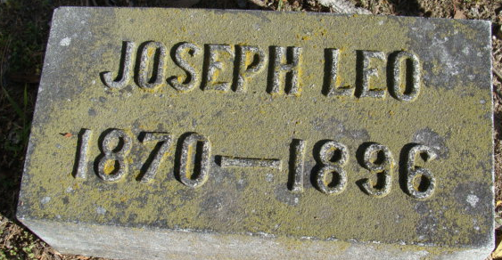
Photo by Alicia Kneuss

Leo J. Wertzberger from tree Reed/Weir Family Tree
Birth 1870 Decatur, Adams, Indiana, USA
Residence 1880 Decatur, Adams, Indiana, USA
Marriage 2 Aug 1893 Adams, Indiana, USA
Death 26 Mar 1896 Decatur, Adams, Indiana, USA
Father Michael Joseph Wertzberger (1847-1933)
Mother Sarah Barbara (Deering) Zerkel (1846-1918)
Spouse Elsie Dana Hughes (1877-1943)

