George Franklin Wertzberger, Sr.
July 9, 1849 – June 4, 1913

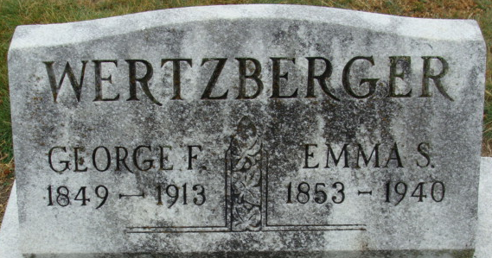
Photo by Alicia Kneuss

George Franklin Wertzberger
in the Indiana, U.S., Death Certificates, 1899-2017
Name George Franklin Wertzberger
Gender Male
Race White
Marital Status Married
Age 63
Birth Date 9 Jul 1849
Birth Place Boston, Massachusetts
Death Date 4 Jun 1913
Death Place Decatur, Adams, Indiana, USA
Death Registration Date 1913
Father Baltz Wertzberger
Mother Magdalene Miller
Spouse Emma
Informant George Wertzberger; Decatur, Indiana
Burial June 6, 1913; Decatur Cemetery

