George Franklin Wertzberger, Jr.
December 10, 1875 – July 15, 1947

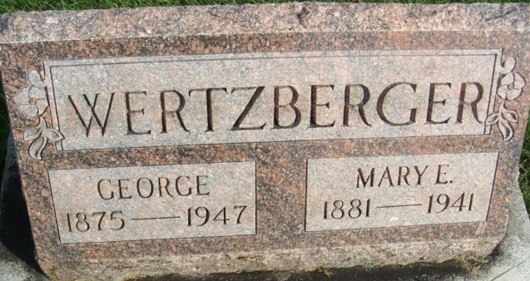
Photo by Alicia Kneuss

George Wertzberger
in the Indiana, U.S., Death Certificates, 1899-2011
Name: George Wertzberger
Gender: Male
Race: White
Age: 71
Marital status: Widowed
Birth Date: 10 Dec 1875
Birth Place: Decatur Indiana
Death Date: 15 Jul 1947
Death Place: Gary, Lake, Indiana, USA
Father: George Wertzberger
Mother: Emma Worrell
Spouse: Mary E Odle
Informant: Walter Wertzberger; Hammond, Indiana
Burial: July 19, 1947; Decatur Cemetery; Decatur, Indiana

