Frank Wertzberger
September 16, 1877 – June 12, 1913

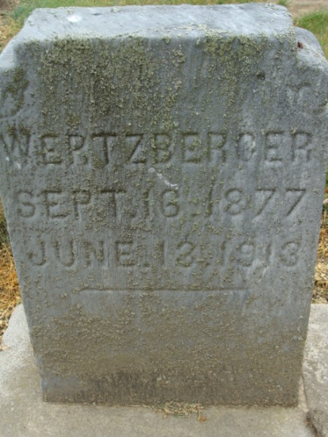
Photo by Alicia Kneuss

DECATUR NEWS
Frank Wertzberger, aged 25, son of the late George Wertzberger, died yesterday afternoon at one o'clock at the home of his brother, George Wertzberger, on Ninth Street. He had been ailing of consumption. His father died a week ago last Wednesday.

Fort Wayne Weekly Sentinel, Allen County, Indiana
June 14, 1913

**
Indiana, U.S., Death Certificates, 1899-2017
Name Frank Wertzberger
Gender Male
Race White
Marital Status Married
Age 36
Birth Date 15 Sep 1877
Birth Place Adams County, Indiana
Death Date 13 Jun 1913
Death Place Decatur, Adams, Indiana, USA
Death Registration Date 1913
Father Geo Wertzberger
Mother Emma Warrel
Informant Can't read
Burial June 15, 1913; Decatur Cemetery

