Emma S. (Warrell) Wertzberger
January 7, 1853 – June 1, 1940

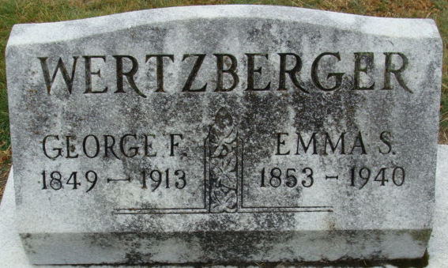
Photo by Alicia Kneuss

WERTZBERGER

Decatur, June 1 – Mrs. Emma Wertzberger, 87, native of this city, died this morning at the home of her son, George Wertzberger of Hammond.
Surviving are four sons, Al, George, Lawrence and Robert, all of Hammond and one daughter, Mrs. C. E. Baughman of this city.
Funeral services will probably be held Monday at Hammond with burial here.

Journal-Gazette, Allen County, Indiana
June 2, 1940

**
Indiana, Death Certificates, 1899-2011
Name: Emma Wertzberger
[Emma Warrel]
Gender: Female
Race: White
Age: 87
Marital status: Widowed
Birth Date: 7 Jan 1853
Birth Place: Vienna Ohio
Death Date: 1 Jun 1940
Death Place: Hammond, Lake, Indiana, USA
Father: Sam Warrel
Mother: Emma Burkhart
Spouse: Geo F Wertzberger
Informant: Alva Wertzberger
Burial: June 3, 1940; Decatur Cemetery; Decatur, Indiana

