Walter G. Werst
August 27, 1938 – May 9, 2014

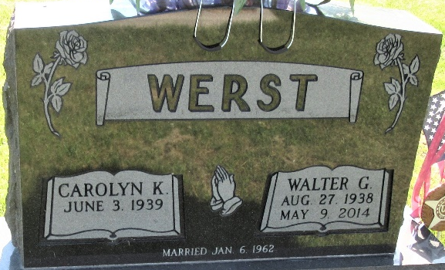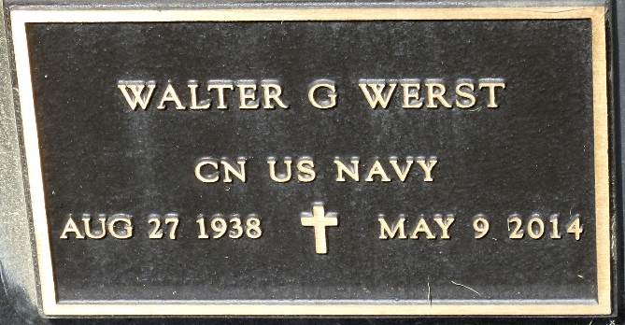
Photo by PLS

Walter G. Werst 75, of Decatur, IN, passed away Friday, May 9, 2014 at his residence. Walter was born on August 27, 1938 in Decatur, IN., to the late Chalmer T. and Marie (Sudduth) Werst. On January 6, 1962 he married Carolyn K. (Fisher).
Walter was a machine operator for the Dana Corporation in Fort Wayne, where he retired from in 1996 after 35 years of service. He served his country in the United States Navy and was a member of the First Presbyterian Church in Decatur.
He is survived by his wife of 52 years Carolyn K. Werst of Decatur; a son Matthew G. (Debbie) Werst of Bartlett, IL; a daughter Melissa J. Sheets of Decatur, 5 grandchildren and 7 great grandchildren. Walt was preceded in death by one sister Aggie Morence.
Visitation will be held on Tuesday May 13, 2014 from 3:00 – 7:00 pm at Haggard Sefton & Hirschy Funeral Home. A Funeral Service will be held at 2:00 p.m. on Wednesday, May 14, 2014 at Haggard-Sefton & Hirschy Funeral Home with Pastor Marcia Cline officiating. Burial will take place in the Decatur Cemetery with Military Graveside Rites conducted by the American Legion Post 43 Color Guard.
Memorials may be made to the Adams County Heart Club.

Haggard & Sefton Funeral Home, Adams County, Indiana
May 10, 2014

