Ruth Virginia (Roop) Werst - Shoaf
April 14, 1942 -

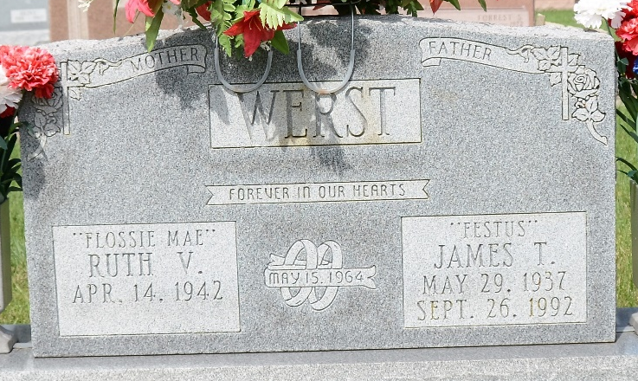
Photo by Deb Curry

Ruth Virginia Roop
in the Indiana, U.S., Birth Certificates, 1907-1944
Name Ruth Virginia Roop
Gender Female
Birth Date 14 Apr 1942
Birth Place Decatur, Adams, Indiana, USA
Father Clarence Roop; age 30
Mother Dorothy Hakes; age 28; 6th child, 4 living
Registration Year 1942
Certificate Number 16889
Roll number 60871.IDX.002_I1415112
Volume Range 31-35
**
Indiana, U.S., Marriage Certificates, 1960-2012
Name Ruth Virginia Werst
[Ruth Virginia Roop]
Gender Female
Marriage Age 55
Birth Date abt 1942
Birth Place Indiana
Marriage Date 15 Feb 1997
Marriage Place Decatur, Adams, Indiana, USA
Marriage Registration Date 1997
Father Clarence Roop
Mother Dorothy Roop
Spouse William Franklin Shoaf
Description Adams-Lake
Notes 2 N
Reference Number 1 Bx1450; Reference Number 2 Tr8555
Certificate Number 001511; Box Number Box 5h

