Patrick Alan Werst
September 11, 1947 – November 15, 2017

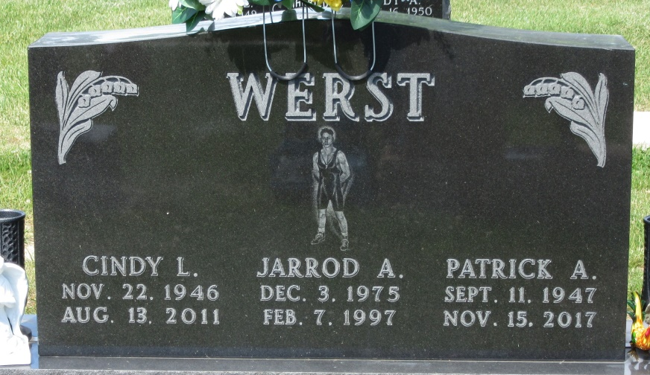
Photo by PLS

Patrick Alan Werst, 70 of Decatur, IN passed away Wednesday, November 15, 2017 at Bluffton Regional Medical Center. Patrick was born on September 11, 1947 in Decatur, IN to the late Joby and Arloa (DeBolt) Werst. On August 1, 1970, he married Cindy L. Durr; she preceded him in death on August 13, 2011.
Patrick worked for Dana Corp. for 38 years.
He is survived by a son, Joby C. Werst of Decatur; a brother, Rex (Gene) Werst of Celina, OH and three grandchildren. Patrick was preceded in death by a son, Jarrod A. Werst, two brothers, Gary D. and Arthur Werst and a sister Delores Burger.
Funeral Service will be held at 11:00 a.m. Saturday, November 18, 2017 with calling prior from 9:00-11:00 a.m. at Haggard-Sefton & Hirschy Funeral Home. Pastor Chris Thurow will be officiating. Burial will be in Decatur Cemetery.
Memorials are to Family Life Care-Hospice.

Haggard-Sefton & Hirschy Funeral Home, Adams County, Indiana
November 15, 2017

