Malissie Jane (Irelan) Werst
September 3, 1881 – February 2, 1958

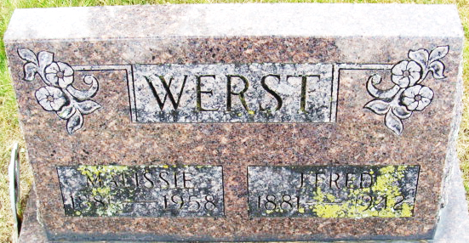
Photo by Alicia Kneuss

Mallissa J. Werst Is Taken By Death
Lifelong Resident Of Decatur Is Dead
Mrs. Mallissa Jane Irelan Werst, 76, a lifelong resident of Decatur, died at 9:30 o'clock Sunday morning of a heart attack at the home of a son, Chester Werst, in Geneva. She had been ill for several weeks.
She was born in Adams County, Sept. 3, 1881, a daughter of Perry and Jane Frisinger-Irelan, and was married to James Fredrick Werst Sept. 20, 1900. Her husband died in March of 1942. Mrs. Werst was a member of the First Methodist Church and the Women of the Moose.
Surviving, in addition to the son at Geneva, are three other sons, Olen Harden of Bell, Calif., Perry Werst of Rockford, O., and Chalmer Werst of Decatur; 10 grandchildren; 10 great-grandchildren, and one brother, Thomas Irelan of Celina, O. One daughter and three brothers are deceased.
Funeral services will be conducted at 1:30 p. m. Wednesday at the Gilllg & Doan Funeral Home, the Rev. Virgil Sexton officiating. Burial will be in the Decatur Cemetery. Friends may call at the funeral home after 5 o’clock this evening until time of the services.
Decatur Daily Democrat; Adams County, Indiana
Monday, February 3, 1958
**
Indiana, U.S., Death Certificates, 1899-2017
Name Mallissa Jane Werst
Gender Female
Race White
Marital Status Widowed
Age 76
Birth Date 3 Sep 1881
Birth Place Adams County, Indiana
Death Date 2 Feb 1958
Death Place Geneva, Adams, Indiana, USA
Death Registration Date 1958
Father Perry Werst [sic – Perry Irelan]
Mother Jane Irelan [sic – Jane Frisinger]
Informant Chalmer Werst; son; Decatur, Indiana
Burial February 5, 1958; Decatur Cemetery; Decatur, Indiana

**
Indiana, U.S., Marriages, 1810-2001
Name Melissa Irelan
Gender Female
Event Type Marriage Registration (Marriage)
Marriage Date 6 Nov 1897
Marriage Place Indiana, United States
Spouse Columbus Harden
Officiator John H Lenhart
Page 337
FHL Film Number 002321471

