Luella P. Werst
March 24, 1908 – June 13, 1991

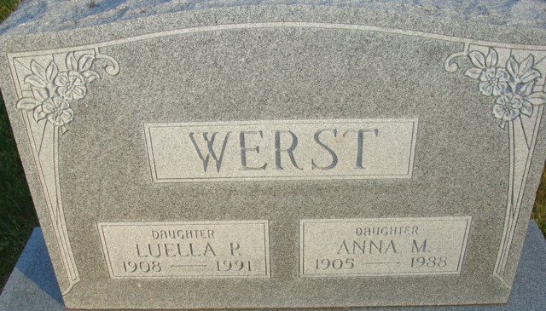
Photo by Alicia Kneuss

Luella P. Werst, 83, of Decatur died Thursday in Lakeside Manor Nursing Home, Decatur. She retired in 1968 from the General Electric Co., Decatur.
Surviving is a sister, Betty Tinkham of Decatur, and a brother, Pete Werst of DeQueen, Ark.
Services are 11 a.m. Monday and calling is 10 a.m. to noon, 2 to 4 and 7 to 9 p.m. tomorrow in Haggard & Armes Funeral Home, Decatur. Burial will be in Decatur Cemetery.
Preferred memorials are gifts to St. Mark's United Methodist Church, Decatur.

News-Sentinel, Allen County, Indiana
Saturday, June 15, 1991
**
Indiana, U.S., Death Certificates, 1899-2017
Name Luella P Werst
Gender Female
Race White
Marital Status Never Married (Single)
Age 83
Birth Date 24 Mar 1908
Birth Place Adams County, Indiana
Death Date 13 Jun 1991
Death Place Decatur, Adams, Indiana, USA
Death Registration Date 1991
Father Rufus Werst
Mother Hester Young
Informant Betty Tinkham; sister; Decatur, Indiana
Burial June 17, 1991; Decatur Cemetery; Decatur, Indiana

