Joby C. Werst
July 10, 1903 – November 7, 1950

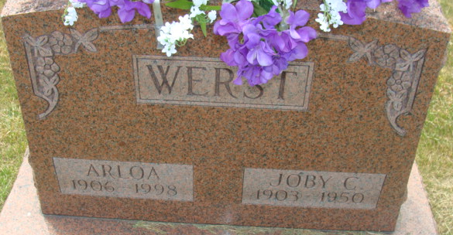
Photo by Alicia Kneuss

Joby C Werst
in the Indiana, U.S., Death Certificates, 1899-2017
Name Joby C Werst
Gender Male
Race White
Marital Status Married
Age 47
Birth Date 10 Jul 1903
Birth Place Adams County, Indiana
Death Date 7 Nov 1950
Death Place Decatur, Adams, Indiana, USA
Death Registration Date 1950
Father Rufus Werst
Mother Hester Young
Informant Mrs. Joby Werst; Decatur, Indiana
Burial November 10, 1950; Maplewood Cemetery; Decatur, Indiana

