Jarrod A. Werst
December 3, 1975 – February 7, 1997

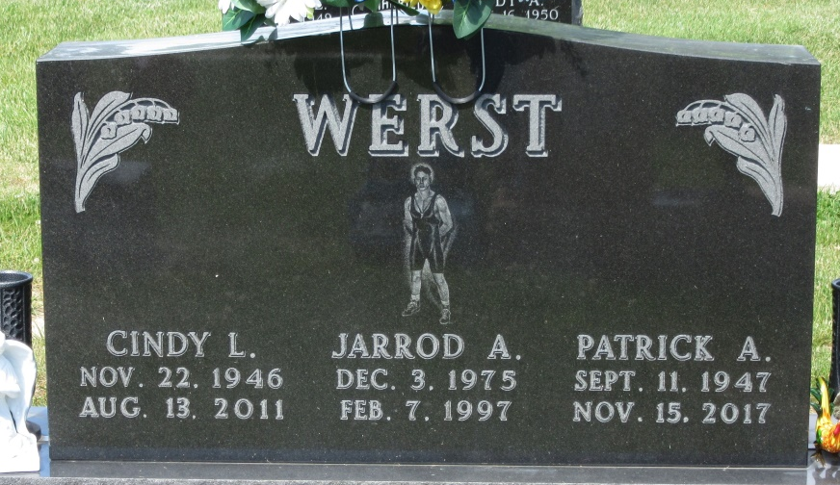
Photo by PLS

Jarrod A. Werst, 21, of Decatur died Friday at Lutheran Hospital. The Bluffton native graduated from Bellmont High School in 1995 and was a member of its 1994 state champion wrestling team.
Surviving is his mother, Cindy; his father, Patrick; a brother, Joby C. of Decatur; his grandmother, Arloa of Berne.
Services are at 1:30 p.m. Monday at Haggard & Armes Funeral Home, with burial in Decatur Cemetery. Calling is 2 to 5 and 7 to 9 p.m. Sunday at the funeral home.
Memorials are to Bellmont Wrestling Team or charity.

News-Sentinel, Allen County, Indiana
Saturday, February 8, 1997
**
Indiana, U.S., Death Certificates, 1899-2017
Name Jarrod A. Werst
Gender Male
Race White
Marital Status Never Married (Single)
Age 21
Birth Date 3 Dec 1975
Birth Place Bluffton, Indiana
Death Date 7 Feb 1997; suicide by gun
Death Place Fort Wayne, Allen, Indiana, USA
Death Registration Date 1997
Father Patrick A. Werst
Mother Cindy L. Durr
Informant Patrick A. Werst; father; Decatur, Indiana
Burial February 10, 1997; Decatur Cemetery; Decatur, Indiana

