James T. “Festus” Werst
May 29, 1937 – September 26, 1992

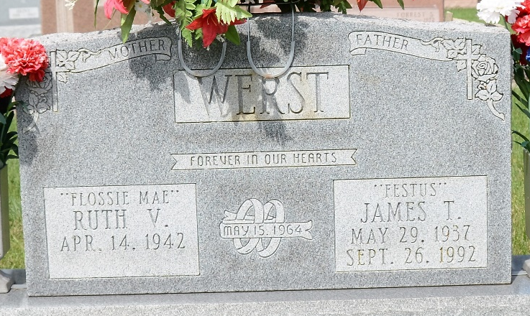
Photo by Deb Curry

James T. Werst, 55, 6281 Main St., Ohio City, died at 6:40 p.m. Saturday in Community Hospital, Coldwater, following an extended illness. He had been a patient at the hospital for eight days. He was born in Griffith, Indiana, May 29, 1937, to Adrian and Lucille M. (Jackson) Werst, and he was married May 15, 1964, to Ruth V. Roop, who survives.
Also surviving are two sons, James Kevin, Decatur, Indiana, and Kerry L., Indianapolis, Indiana; three daughters, Mrs. John (Teresa A. ) Baker, Ohio City, Mrs. Robert (Starla K.) Sheets, Mendon, and April Werst, at home a step-son, Eric L Roop, Orlando, Florida; a brother, Richard, Celina; a sister Mrs. Von (Susan) Call, Willshire, Ohio; four grandchildren and six step grandchildren. He was preceded in death by a stepson Darrell Roop.
Mr. Werst was an employee of Decatur Industries from January 1, 1970, until he retired due to ill health in 1990.
Services will be held at 2 p.m. Wednesday in the Zwick-Sefton and Jahn Funeral Home, Decatur, the Rev. Edward King, officiating. Burial will be in Decatur Cemetery. Friends may call 3-6 and 8-10 p.m. Tuesday in the funeral home. All are Ohio times.
Memorial contributions may be directed to the Indiana Ronald McDonald House or the Shriners Hospitals for Crippled Children.

Celina Daily Standard, Mercer County, Ohio
September 28, 1992

