Gary D. Werst
November 30, 1943 – July 5, 2016

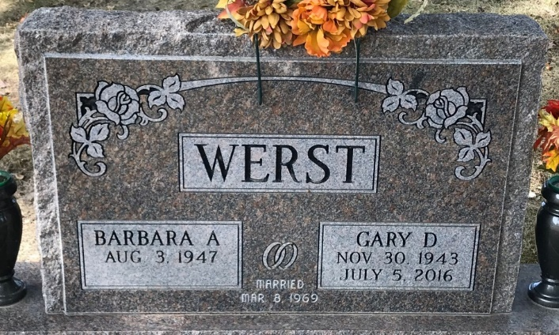
Photo by PLS

Gary D Werst
in the Indiana, U.S., Death Certificates, 1899-2017
Name Gary D Werst
Gender Male
Race White
Age 72
Birth Date 30 Nov 1943
Birth Place Decatur, Indiana
Death Date 5 Jul 2016
Death Place Decatur, Adams, Indiana, USA
Death Registration Date 2016
Father Joby Werst
Mother Edna Debolt
Spouse Barbara A Williams
Informant Barbara Werst; spouse; Decatur, Indiana
Burial Decatur Cemetery; Decatur, Indiana
Certificate Number 033557

