Elnora L. Werst
May 7, 1917 – March 16, 1931

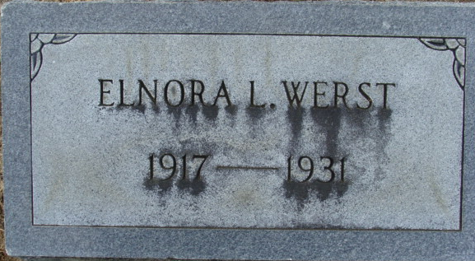
Photo by Alicia Kneuss

Elnara Werst
in the Indiana, U.S., Death Certificates, 1899-2017
Name Elnora Werst
Gender Female
Race White
Marital Status Single
Age 13
Birth Date 7 May 1917
Birth Place Indiana
Death Date 16 Mar 1931
Death Place Decatur, Adams, Indiana, USA
Death Registration Date 1931
Father Rufus Werst
Mother Hester Young
Informant Ruffus Werst
Burial March 18, 1931; Decatur Cemetery

