Cindy L. (Durr) Werst
November 22, 1946 – August 13, 2011

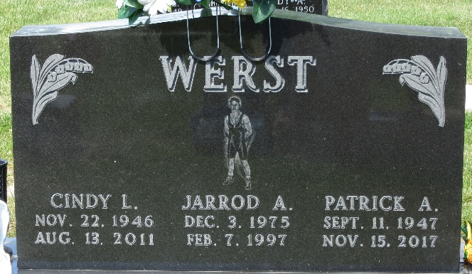
Photo by PLS

Cindy L. Werst, 64, of Decatur, passed away Saturday August 13, 2011, at Visiting Nurse and Hospice Home in Fort Wayne. She was born on November 22, 1946, to the late Herman and Mary (Fuhrman) Durr in Bluffton. On August 1, 1970, Cindy married Patrick A. Werst; he survives.
Mrs. Werst attended New Hope Church in Decatur and was a former employee of Decatur G.E. She worked as an assistant at Walmart Pharmacy, and she also worked with special needs students in the Adams and Wells school systems and volunteered at Northwest Elementary School.
Other survivors include son Joby C. (Monica) Werst of Decatur; one sister, Connie (Jim) Baumgartner of Decatur; three grandchildren; and several nieces and nephews. She was preceded in death by son Jarrod A. Werst and a brother, Chuck Durr.
Visitation will be held on Tuesday August 16 from 3 to 8 p.m. at Haggard Sefton and Hirschy Funeral Home. Funeral services will be on Wednesday, August 17, at 10:30 a.m., also at the funeral home. Burial will be at the Decatur Cemetery. Pastor Kevin August will be officiating.
Memorial contributions may be made to New Hope Church.

Bluffton News-Banner, Wells County, Indiana
Monday, August 15, 2011

