Barbara A. (Williams) Werst
August 3, 1947 – August 8, 2020

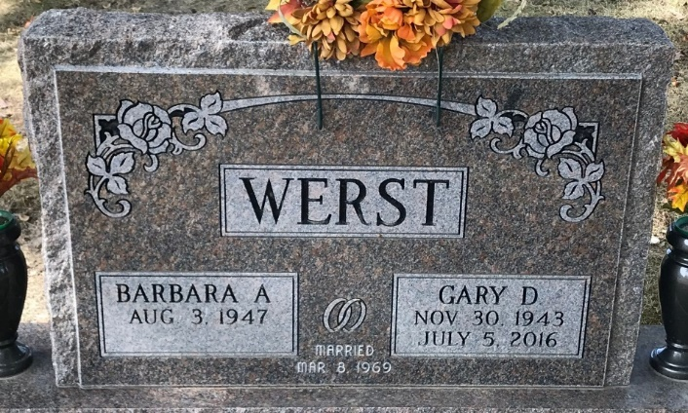
Photo by PLS

Barbara A. Werst, 73, of New Haven, Indiana passed away on Saturday, August 8, 2020, at Visiting Nurse Hospice Home in Fort Wayne, Indiana. She was born on August 3, 1947, to the late Donald L. Williams and the late Joyce (Mengerink) Williams. Barb was united in marriage to Gary D. Werst on March 8, 1969, and he preceded her in death on July 5, 2016.
Barb was very proud in the role as a homemaker and raising her family. After raising her children, she worked at Goodies for a few years. In her spare time she enjoyed watching I.U. basketball (men’s or women’s). She looked forward to her Saturday telephone conversations with her family to discuss the upcoming or progress of the Notre Dame Football game. For over 40 years, she enjoyed spending time at the Randall Lake in southern Michigan with her husband and family, where they fished, boated, and cherished their time together.
Survivors include two sons, Scott (Caralee) Werst of Ossian, Indiana and Brian (Kimberley) Werst of Lima, Ohio; daughter, Tammi (Mitchal) Milholland of New Haven, Indiana; two brothers, Don (Barb) Williams Jr. of Minnesota and Gary Williams (Companion Susan Fuelling) of Decatur, Indiana; two sisters, Cindy Keen (Companion Bob Romero) of Decatur, Indiana and Sharon (Russ) Colegrove of Spencerville, Indiana; three grandchildren, Trevor Werst, Justin Werst and James Werst; and furry companions, Buddy and Panda. Barbara was preceded in death by her son, Jefferey D. Werst.
Private Graveside services will be held at Decatur Cemetery.
Friends will be received from 6:00-8:00 p.m. Wednesday, August 12, 2020, at the Zwick & Jahn Funeral Home- Decatur. Casual attire is requested by the family.
Preferred memorials can be given to Allen County ASPCA.

Zwick & Jahn Funeral Home, Adams County, Indiana
August 10, 2020

