Treva A. (Ray) Werling
June 14, 1902 – May 18, 2007

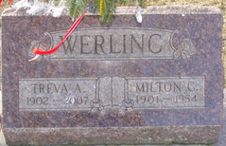
Photo by Alicia Kneuss

Treva Werling, 104, of Fort Wayne, formerly of Preble, died Friday, May 18, 2007, at Parkview North Hospice, Fort Wayne. Born June 14, 1902, in Berne, she was the daughter of Rosie (Fravel) and John Ray. She married Milton Werling on June 14, 1923, worked as a homemaker and seamstress for Schafer Glove Company, and Sears.
She is survived by two daughters, Mrs. George (Ruth) Abels of Fort Wayne and Mrs. Gerald (Lois) Gehrig of Decatur; 12 grandchildren; 28 great- grandchildren; and six great-great grandchildren. She was preceded in death by her husband, Milton Werling; two sons, Donald and Jean Werling; and two grandsons.
Service is 1 p.m. Tuesday at Haggard & Sefton Funeral Home, Decatur, with visitation one hour prior. The Rev. Sid Gauby and The Rev. Russ Abel officiating. Visitation also from 5 to 8 p.m. Monday at the funeral home. Memorials to Parkview North Hospice.

Journal-Gazette, Allen County, Indiana
May 20, 2007

