Phyllis Jane (Bowman) Werling
April 8, 1929 – January 14, 1997

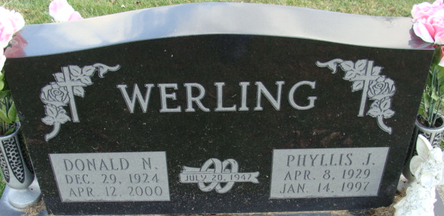
Photo by Alicia Kneuss

Phyllis J. Werling, 67, of Decatur died Tuesday at home. The Decatur native retired in 1991 from North Adams Community Schools after 21 years.
Surviving is her husband, Donald; a daughter, Peggy Werling of Decatur; a son, Michael of Decatur; her stepmother, Florence Bowman of Keystone; half-sisters, Joyce Widmann and Jane Bowman, both of Fort Wayne, Betty Heckley of Springfield, Ohio, and Anna Bowman of Keystone; a half-brother, Kenneth Bowman of Yoder; and a grandchild.
Services are 2 p.m. Friday in Zwick-Sefton & Jahn Funeral Home, Decatur, where calling is 2 to 4 and 7 to 9 p.m. Thursday. Burial will be in Decatur Cemetery.
News-Sentinel, Allen County, Indiana
Wednesday, January 15, 1997
**
Indiana, U.S., Death Certificates, 1899-2017
Name Phyllis J Werling
[Phyllis J Bowman]
Gender Female
Race White
Marital Status Married
Age 67
Birth Date 8 Apr 1929
Birth Place Decatur, Indiana
Death Date 14 Jan 1997
Death Place Decatur, Adams, Indiana, USA
Death Registration Date 1997
Father Howard Bowman
Mother Hazel Peterson
Spouse Donald N Werling
Informant Donald N. Werling; husband; Decatur, Indiana
Burial January 17, 1997; Decatur Cemetery; Decatur, Indiana

