Larry Gene Werling
February 9, 1949 – December 2, 1966

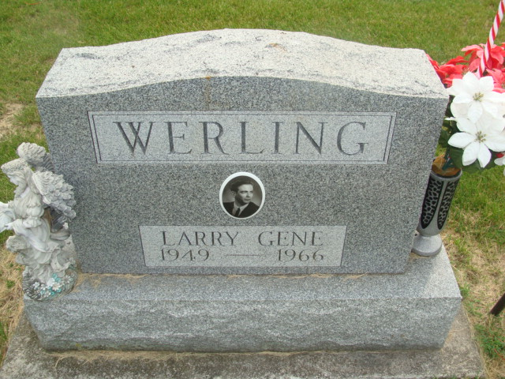
Photo by Alicia Kneuss

3 Decatur Boys Die on Crossing

Decatur – Three 17-year-old Decatur High School students, en route to their part time employment at Krick-Tyndall Tile Co. after classes, died instantly at 3:51 pm Friday when a westbound, through Erie-Lackawanna Railroad passenger train smashed into their car at the Tenth Street crossing.
Dead were: Daniel P. Harden, said to have been the driver; Larry Gene Werling and James M. Kenney, R.R. 2.
Police chief Grover Odle said the train, after hitting the car, carried the wreckage six and one-half blocks. The three were pinned in the wreckage.
Richard Linn, Adams County Coroner, said the bodies were “pretty well broken.” Cause of the accident had not been determined late Friday night. There were flashers at the crossing. While there was some ice on the street, no skid marks were visible, authorities said.
Werling, son of Jean and Patricia Werling, R.R. 4, had been staying in this city with an uncle and aunt, Mr. and Mrs. Gerald Gehrig. Also surviving are a brother, Dennis J.; two sisters, Linda Darlene, Glenda Lois; the grandparents, Mr. and Mrs. Charles Roebuck, R. R. 2, Rockford, Ohio, Mrs. Treva Werling, Mrs. Mary Bloxham, both of Fort Wayne.
Friends may call at the Winteregg-Linn Funeral Home after 7 pm Sunday. Services will be there at 2 pm Tuesday.
Harden’s survivors are the parents, Paul L. and Catherine Sovine Harden; six sisters, Nancy, Joanne, both at home, Shirley, West Lafayette, Mrs. James Brunner, Detroit, Mich., Mrs. Reginald Welch, Bloomington, and Mrs. Richard Fravel, Great Falls, Mont.
His body is also at the Winteregg-Linn Funeral Home where friends may call from 10 am Sunday until 11 am Monday, then at St. Paul’s Missionary Church prior to 2 pm services.
The body of Kenney is at the Zwick Funeral Home.

Journal-Gazette, Allen County, Indiana
December 3, 1966
Page 1

**
Three Decatur high school ... when passenger train
Three Decatur high school seniors en route to their part time employment at the Krick-Tyndall Tile Co. were killed instantly when a westbound Erie Lackawanna railroad passenger train smashed into their car at the Tenth Street crossing in Decatur Friday at 4:51 p.m.
Dead are Daniel Paul Harden, 17, 922 W. Monroe St., driver of the auto, James Michael Kenney, 17, of route 5, and Larry Gene Werling, 17, route 4.
The train, after hitting the auto, carried the car six and one-half blocks, before finally coming to a rest just west of the west end of Duo-Marine, Inc., located in Industrial Park. Richard Linn, county coroner, said the bodies were "pretty well broken."
H. R. Herzeg, Huntington, engineer of the train, stated that the car came onto the railroad tracks and suddenly stopped right in the middle of the tracks. The flasher lights at the crossing were on, according to Herzog. Their (sic) was ice on the street but no skid marks were evident. All three youths were pinned in the auto for 45 minutes following the accident. The train engine and a wrecker were used from opposite ends of the car to pry the bodies from the wreckage.
The Harden youth had worked for Zintsmaster Motors up to about a month ago, before taking a job at the tile company. The Kenney boy had previously been employed by the Happy-Humpty Drive-in in Decatur. The auto was taken to the Les Sheets garage.
Daniel Paul Harden
Daniel Paul Harden was born in Fort Wayne May 10, 1949, a son of Paul L. and Catherene Sovine-Harden, and was a life-long resident of Decatur, residing with his parents at 922 West Monroe Street.
The youth attended the St. Paul Missionary Church.
Surviving in addition to the parents are six sisters, Mrs. James (Barbara) Bruner of Detroit, Mich., Miss Shirley Harden of West Lafayette, Mrs. Reginald (Sharon) Welch of Bloomington, Mrs. Richard (Evelyn) Fravel of Great Falls, Mont., and Misses Nancy and Joanne Harden both at home; and the grandparents.
Funeral services will be conducted at 2 p.m. Monday at the St. Paul Missionary Church, with Rev. Robert R. Welch officiating. Burial will be in the Decatur Cemetery. Friends may view at the Winteregg-Lynn Funeral Home after 10 a.m. Sunday until 11:30 a.m. Monday. The body will lie in state at the church from 12 noon Monday until time of the services.
James Michael Kenney
James Michael Kenney was born in Decatur Feb. 10, 1949, a son of William E. and Mary Crosby-Kenney. His father preceded him in death Feb. 10, 1963. The young man was a member of Zion Lutheran Church and the Walther league of the church.
Surviving are his stepfather and mother, Mr. and Mrs. Gilbert Thieme of route 5, six miles east of Decatur; two brothers, a 3c John W. Kenney, stationed in Germany, and Patrick E. Kenney, at home; three sisters, Misses Kathryn Anne, Julie and Laura Kenney, all at home; three stepsisters, Mrs. James (Karen) Reidenbach of Decatur, and Misses Beverly and Susan Thieme; a stepbrother, Lanny Thieme; the grandmothers, Mrs. Fred Crosby of Decatur route 3 and Mrs. Jessie Kenney of Avilla; and a step grandmother, Mrs. Louise Thieme of Decatur.
Funeral services will be conducted at 1:30 p.m. Tuesday at the Zwick Funeral Home and at 2 p.m. at the Zion Lutheran Church, with Rev. Richard C. Ludwig officiating. Burial will be in the Decatur Cemetery.
Friends may call at the funeral home after 4 p.m. Sunday until time of the services.
The family prefers memorials to the Zion Lutheran building fund.
[right side of obit article is cut off]

**
Indiana, Death Certificates, 1899-2011

Name: Larry Gene Werling
Gender: Male
Race: Caucasian (White)
Age: 17
Marital Status: Never Married (Single)
Birth Date: 9 Feb 1949
Birth Place: Indiana
Death Date: 2 Dec 1966
Death Place: Decatur, Adams, Indiana, USA
Father: Jean A Werling
Mother: Patricia E. Roebuck
Informant: Jean Werling; father; Fort Wayne, Indiana
Burial: December 6, 1966; Decatur Cemetery; Decatur, Indiana

