Christina (Schmidt) Werling
November 2, 1867 – March 8, 1950

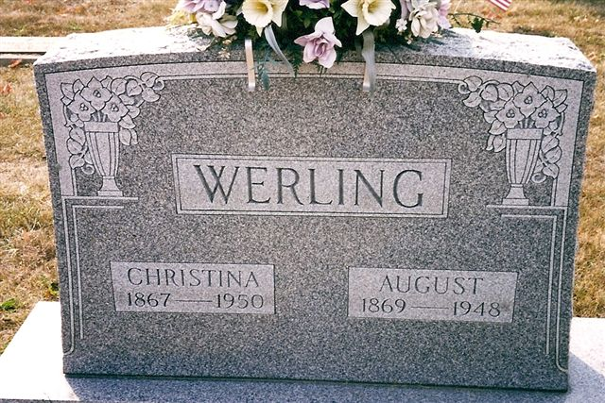
Photo by Deb Curry

Mrs Christina Werling
in the Indiana, U.S., Death Certificates, 1899-2017
Name Mrs Christina Werling
[Mrs Christina Schmidt]
Gender Female
Race White
Marital Status Widowed
Age 82
Birth Date 2 Nov 1867
Birth Place Indiana
Death Date 8 Mar 1950
Death Place Decatur, Adams, Indiana, USA
Death Registration Date 1950
Father John Schmidt
Mother Catherine
Informant Mrs. Herman Dierkes; Decatur, Indiana
Burial March 10, 1950; Decatur Cemetery; Decatur, Indiana

