August W. Werling
November 11, 1869 – October 23, 1948

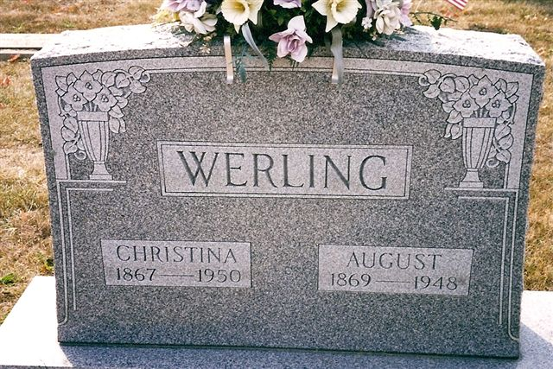
Photo by Deb Curry

August Werling
in the Indiana, U.S., Death Certificates, 1899-2017
Name August Werling
Gender Male
Race White
Marital Status Married
Age 78
Birth Date 11 Nov 1869
Birth Place Ruble Twp Adams Co Indiana
Death Date 23 Oct 1948
Death Place Decatur, Adams, Indiana, USA
Death Registration Date 1948
Father David Werling
Mother Augusta Bley
Spouse Chistina Schmidt; age 76
Informant Mrs. Christina Werling; Decatur, Indiana
Burial October 26, 1948; Decatur Cemetery; Decatur, Indiana

