Emma Werder
December 13, 1861 – September 23, 1933

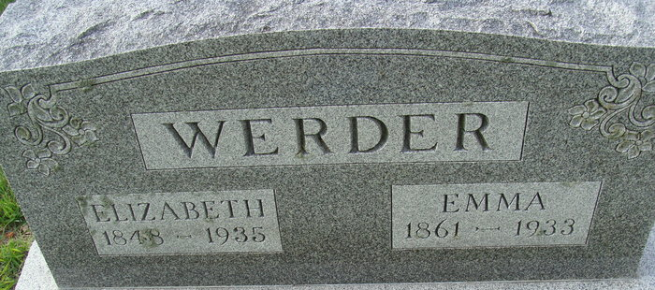
Photo by Alicia Kneuss

Ema Werder
in the Indiana, U.S., Death Certificates, 1899-2017
Name Ema Werder
Gender Female
Race White
Marital Status Single
Age 71
Birth Date 13 Dec 1861
Birth Place Ohio
Death Date 23 Sep 1933
Death Place Decatur, Adams, Indiana, USA
Death Registration Date 1933
Father Henry Werder
Mother Anna Myers
Informant Lizzie Werder; Decatur, Indiana
Burial September 25, 1933; Decatur Cemetery

