Thora A. (Kauffman) Wenning
September 9, 1919 – January 2, 2001

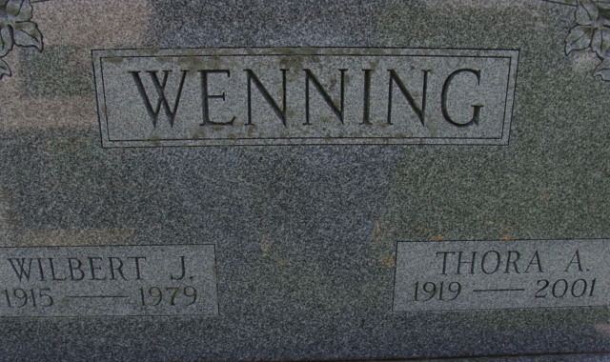
Photo by Alicia Kneuss

Thora A Ray Wenning, 81, of Decatur, who managed Decatur Mobile Home Park for 19 years, died Tuesday, 2nd Jan 2001, at Woodcrest Nursing Center.
The Adams County native was a member of United Brethren in Christ Church, American Legion, VFW and Women of the Moose auxiliaries.
Surviving are sons Donald D. of Decatur and Ronald W. of Berne; stepsons Timothy of Kalamazoo, Michigan, Todd of Cincinnati, Theodore of Decatur and Andrew of Craigville; a daughter Jean A Shoaf of Decatur; and a stepdaughter Myra Wigger of Decatur. She was preceded in death by brothers Raymond and Gorman Kauffman.
Services are 10.00am Thursday with calling from 2 to 8pm today. Burial will be at Decatur cemetery.
News-Sentinel, Allen County, Indiana
January 3, 2001
**
Indiana, U.S., Death Certificates, 1899-2017
Name Thora A Wenning
[Thora A Kauffman]
Gender Female
Race White
Marital Status Widowed
Age 81
Birth Date 9 Sep 1919
Birth Place Indiana
Death Date 2 Jan 2001
Death Place Decatur, Adams, Indiana, USA
Father Daniel D Kauffman
Mother Minnie Jane Essex
Informant Ronald W. Ray; son; Decatur, Indiana
Burial January 4, 2001; Decatur Cemetery; Decatur, Indiana

