Sara Megan Wenning
May 17, 1979 – January 11, 1989

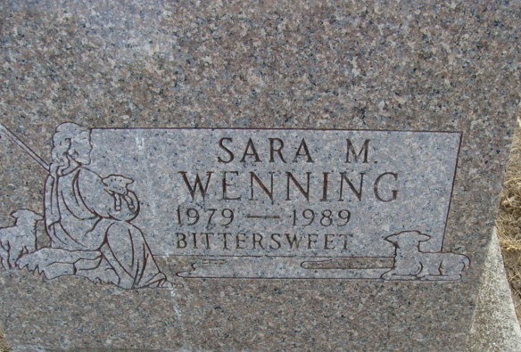
Photo by Alicia Kneuss

Sara Megan Wenning
in the Indiana, U.S., Death Certificates, 1899-2017
Name Sara Megan Wenning
Gender Female
Race White
Marital Status Never Married (Single)
Age 9
Birth Date 17 May 1979
Birth Place Fort Wayne, Indiana
Death Date 11 Jan 1989
Death Place Huntington, Huntington, Indiana, USA
Death Registration Date 1989
Father Theodore Wenning
Mother Ann Wenning
Informant Theodore Wenning; father; Decatur, Indiana
Burial January 14, 1989; Decatur Cemetery; Decatur, Indiana

