Thelma Mae (Maddux) Wenger
August 15, 1913 – March 16, 1973

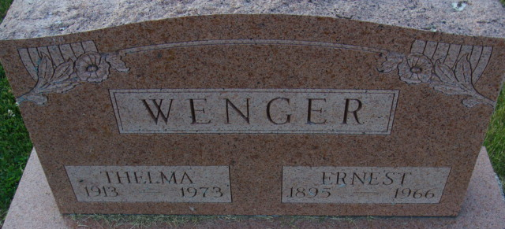
Photo by Alicia Kneuss

Thelma Wenger is Taken by Death

Mrs. Thelma M. Wenger, 59, of 1039 Elm Street, widow of Ernest Wenger, died at 5:30 a.m. Friday at the home of her daughter, Mrs. Glen (Naomi) Woodin, of Fort Wayne. She was born on August 15, 1913, in Minot, South Dakota, the daughter of Archibald and Arminda Reynolds-Maddux, and was married on December 14, 1933, to Ernest Wenger, who died on February 17, 1966.
Mrs. Wenger was a member of the V.F.W. Auxiliary and lived in Decatur since 1949.
Surviving are the daughter, one son, Robert A. Wenger of Monroeville; two sisters, Mrs. Raul (Mary) Smith of Reiffsburg and Mrs. Naomi Cousino of Detroit Beach, Mich.; two brothers, Robert Maddux of Temperance, Mich., and Elroy Maddux of Florida, and eight grandchildren. Two sisters and one brother preceded her in death.
Funeral services will be held at 2 p.m. Monday at the Winteregg-Linn Funeral Home, with Rev. William C. Feller officiating. Burial will be in the Decatur Cemetery. Friends may call at the funeral home after 7 p.m. today.

Decatur Daily Democrat, Adams County, Indiana
Saturday, March 17, 1973

