Ernest Wenger
February 9, 1895 – February 17, 1966

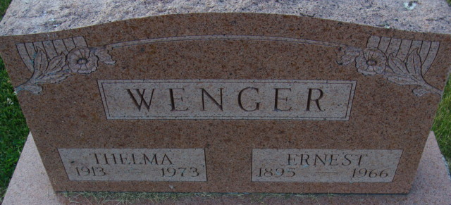
Photo by Alicia Kneuss

Ernst Wenger
in the Indiana, U.S., Death Certificates, 1899-2017
Name Ernst Wenger
Gender Male
Race Caucasian (White)
Marital Status Married
Age 71
Birth Date 9 Feb 1895
Birth Place Switzerland
Death Date 17 Feb 1966
Death Place Decatur, Adams, Indiana, USA
Death Registration Date 1966
Father John Wenger
Mother Elizabeth Wengerd
Informant Thelma Wenger; wife; Decatur, Indiana
Burial February 19, 1966; Maplewood Cemetery; Decatur, Indiana

