Daniel Jay Welty
June 17, 1948 – March 16, 1949

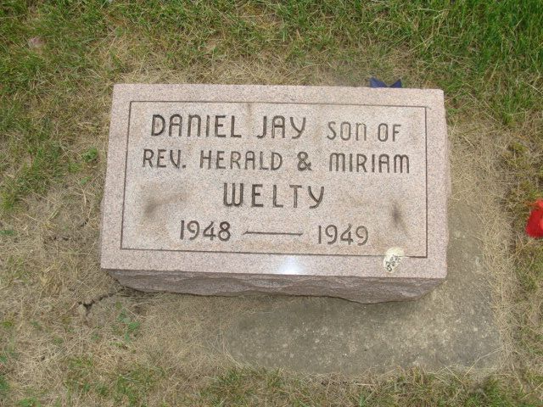
Photo by Alicia Kneuss

Daniel P Welty
in the Indiana, U.S., Death Certificates, 1899-2017
Name Daniel J. Welty
Gender Male
Race White
Age 8 months, 29 days
Birth Date 17 June 1948
Birth Place Adams County, Indiana
Death Date 16 Mar 1949
Death Place Decatur, Adams, Indiana, USA
Death Registration Date 1949
Father Harold J Welty
Mother Steiner
Informant Harold Welty; Decatur, Indiana
Burial March 17, 1949; Decatur Cemetery; Decatur, Indiana

