Vere Steele Welker
August 29, 1908 – March 13, 1979

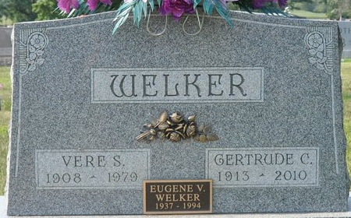
Photo by Deb Curry

Era Sleel Welker
in the Indiana, U.S., Birth Certificates, 1907-1944
Name Erv Steel Welker
Gender Male
Birth Date 29 Aug 1908
Birth Place Decatur, Adams, Indiana, USA
Father Melvin Welker; age 29
Mother Rosy Steel; age 28; 1st child
Certificate Number 321
Roll number 45385_358777
Volume Range 28 - 32
**
Indiana, U.S., Marriage Certificates, 1960-2012
Name Vere S Welker
Gender Male[ Race White; Marriage Age 26
Birth Date 23 Aug 1908
Birth Place Decatur, Adams, Indiana
Marriage License Date 7 Feb 1935
Marriage Date 8 Feb 1935; Marriage Place Allen, Indiana, USA
Residence Place Fort Wayne, Indiana
Father Melvin Welker; Mother Rose Welker
Spouse Gertrude Gase
Officiator Edward Burns Martin
**
Florida Death Index, 1877-1998
Name: Vere S Welker
Death Date: 13 Mar 1979
County of Death: Lee; State of Death: Florida
Age at Death: 70
Race: White
Birth Date: 23 Aug 1908

